

IBM DATA ANALYTICS ASSIGNMENT - 4

Name: k khyathi varshinee

Mail Id: varshinee.21bce7209@vitapstudent.ac.in

Lecture Name: Indra Sir

Now let us create some Basic and LOD expressions by some calculations

Now let us see the Basic calculations

1st visualization

Profit percentage for the categories

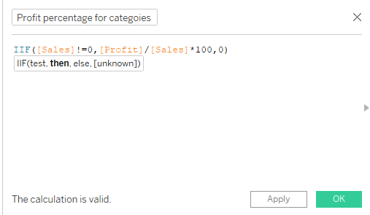

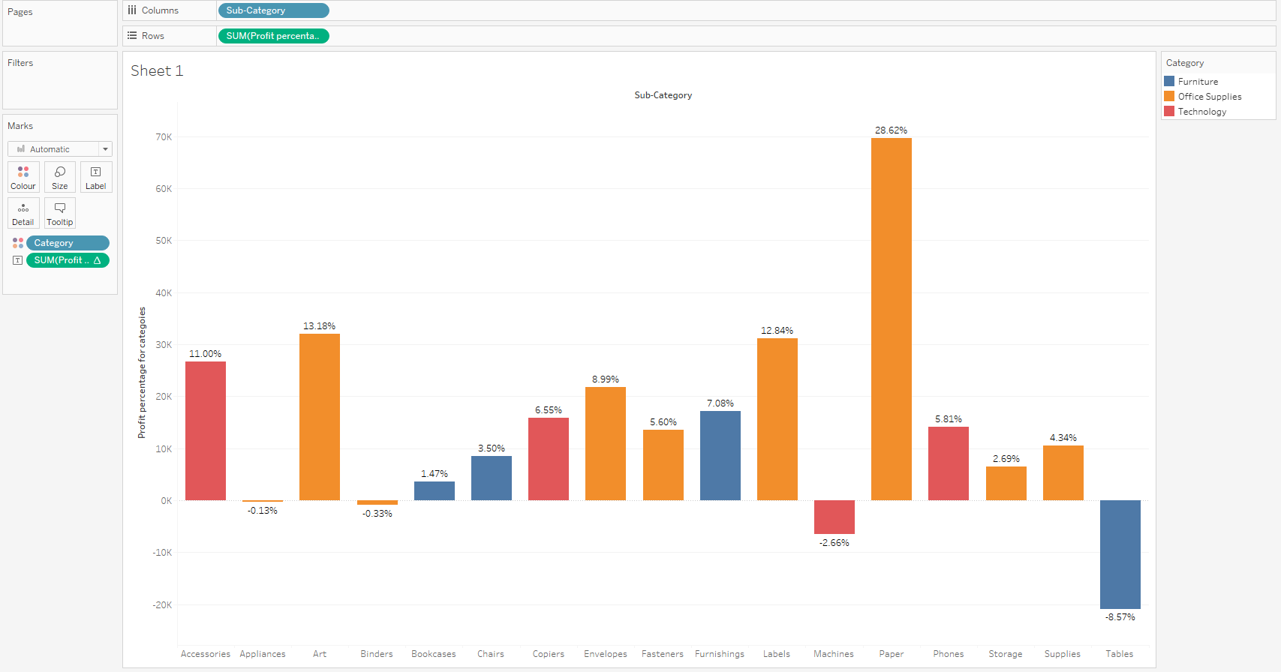

2nd visualization

Revenue per unit as per market

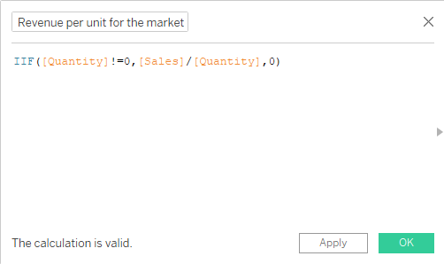

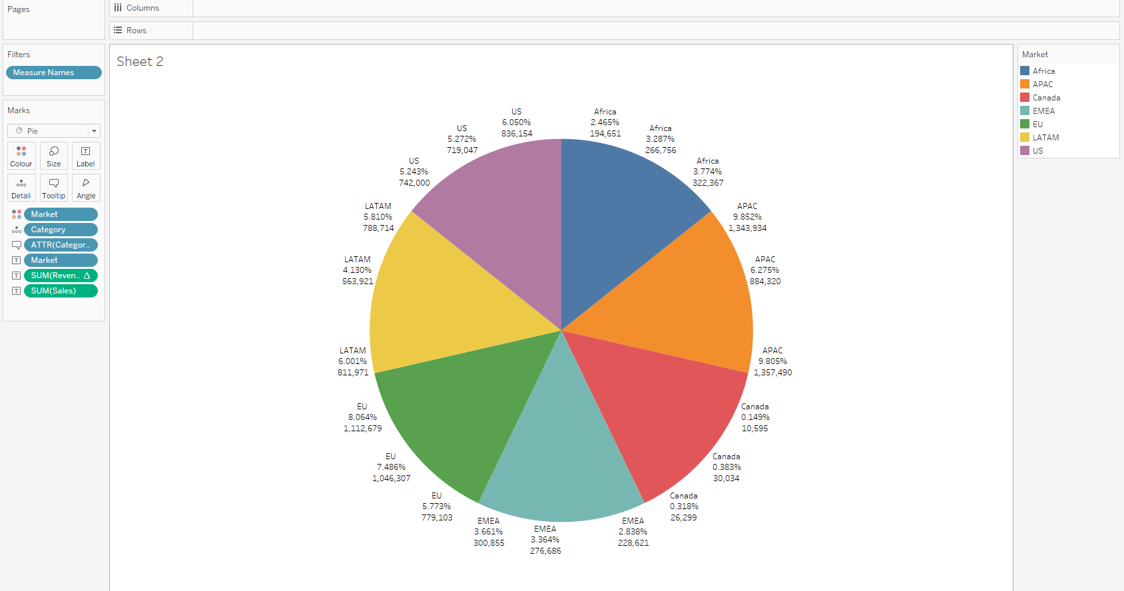

3rd visualization

Absolute Cost price of the product

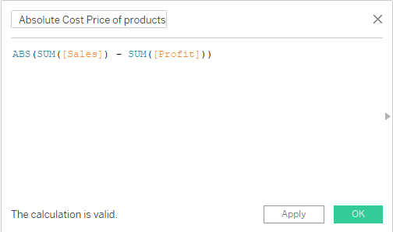

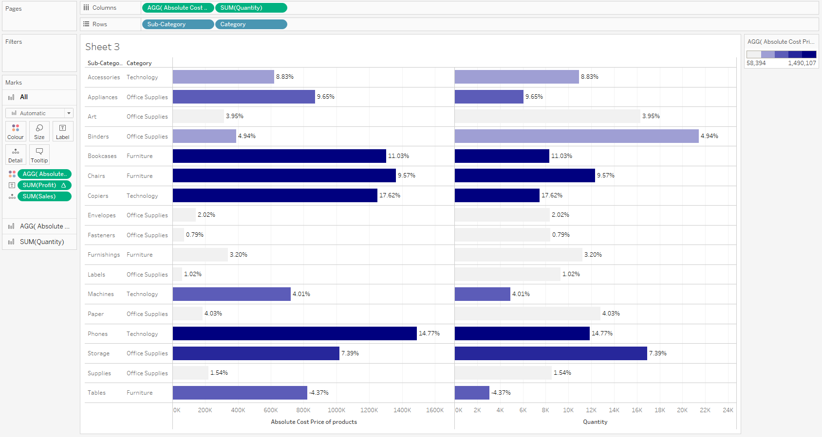

4th visualization

Total Cost

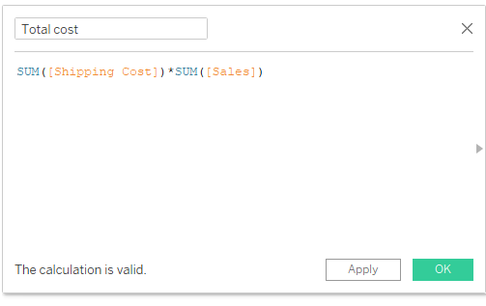

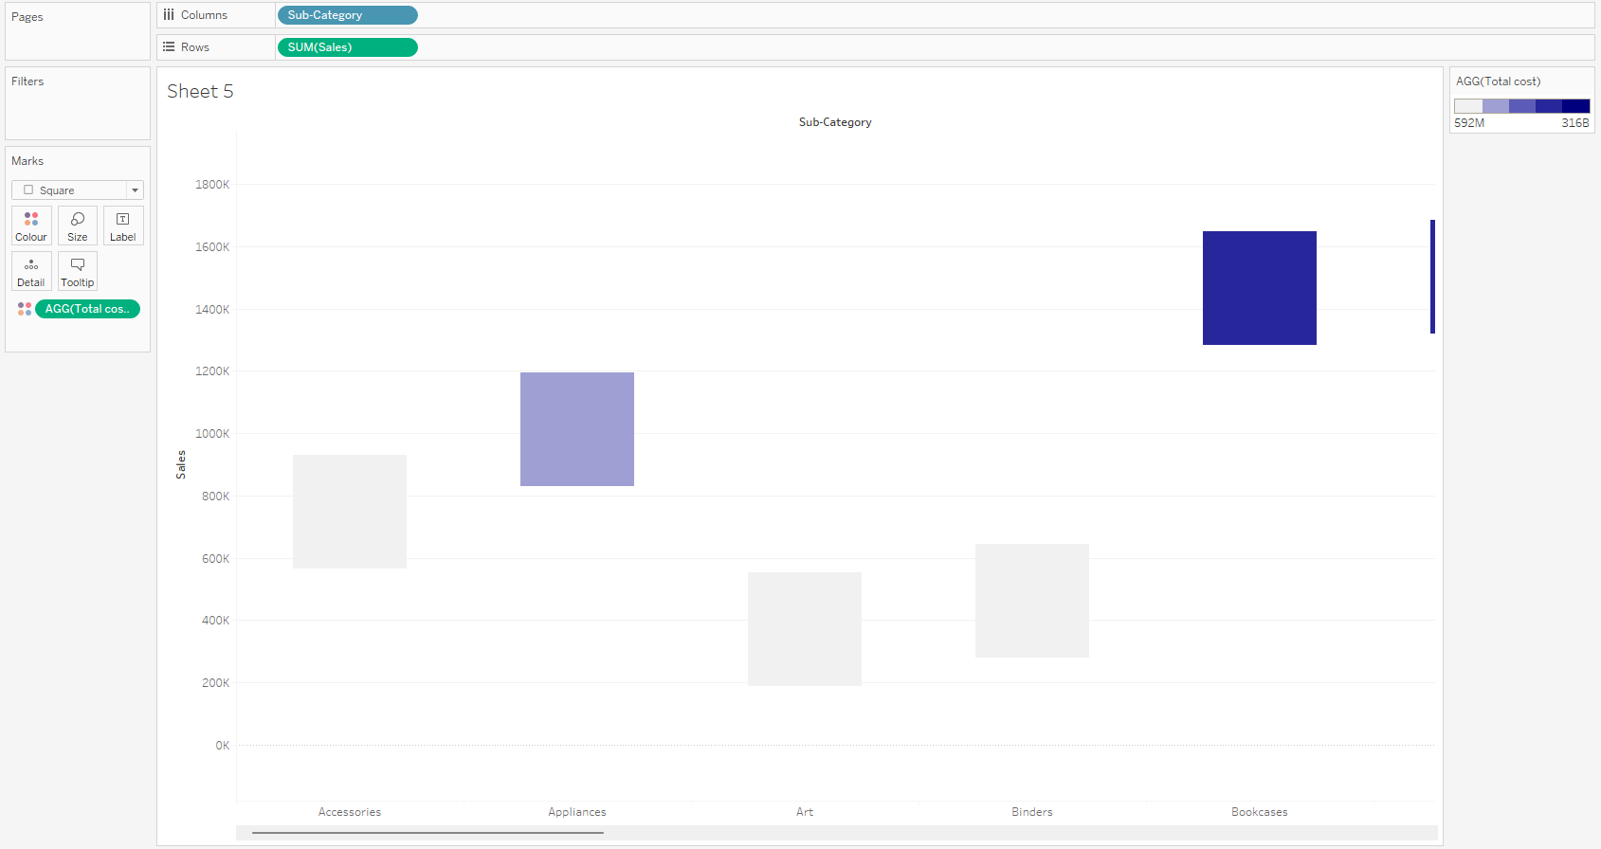

Now Let us see the Some LOD expressions

5th visualization

Sales per Customer Name

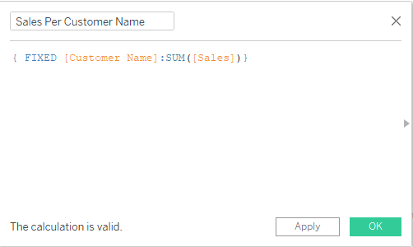

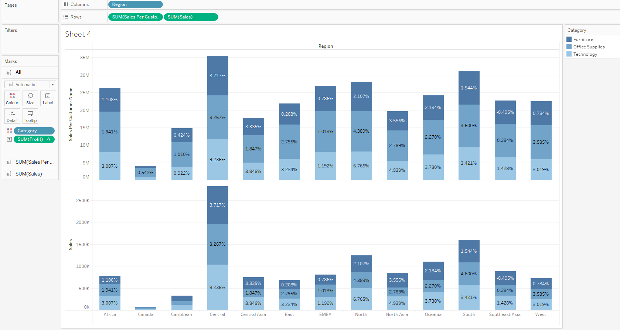

6th visualization

Sales for the World cup playing Countries

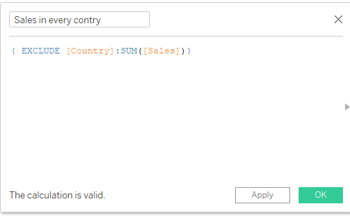

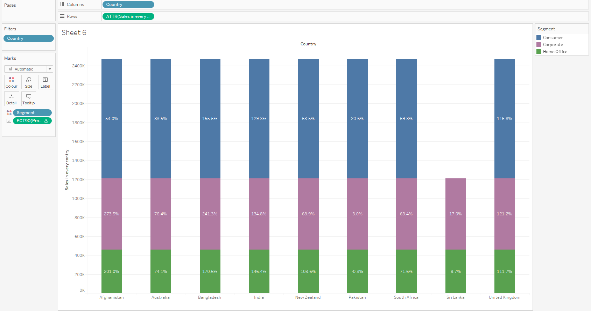

7th Visualization

Country Maximum Profits

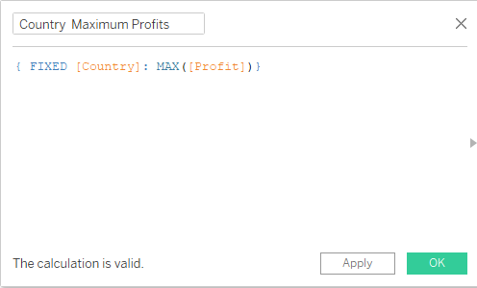

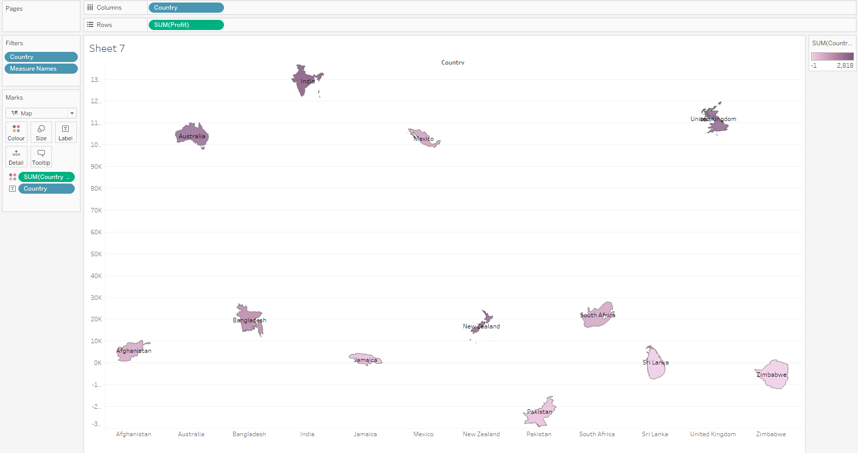

8th visualization

Minimum Sales in some region

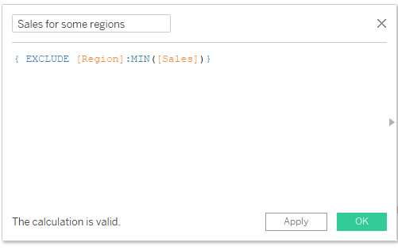

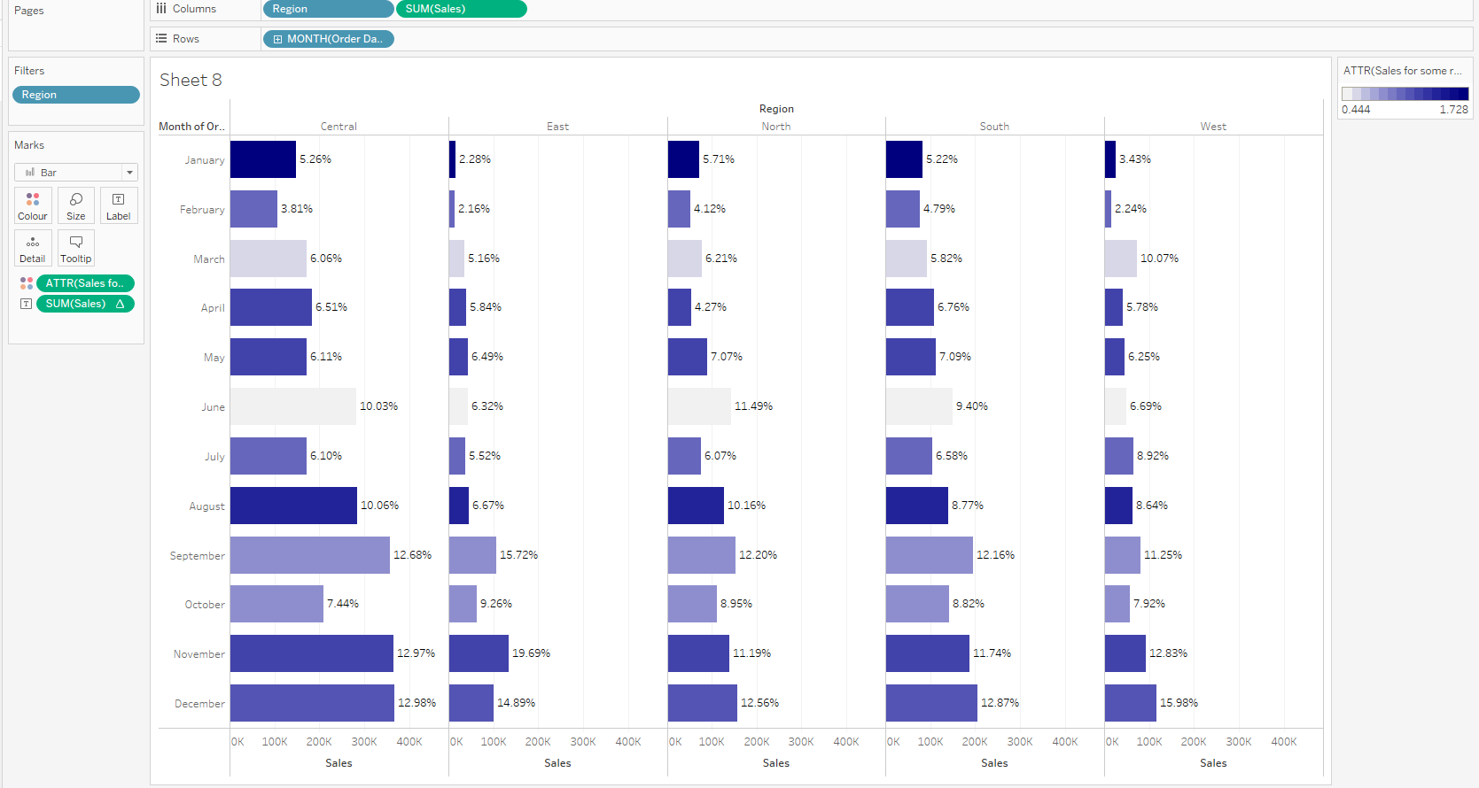

9th visualization

Total Profits per day

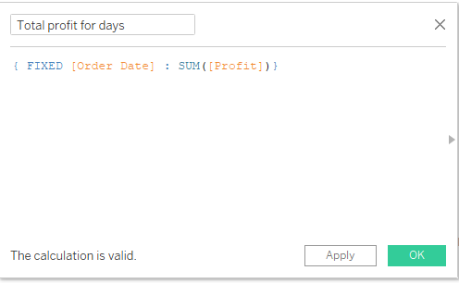

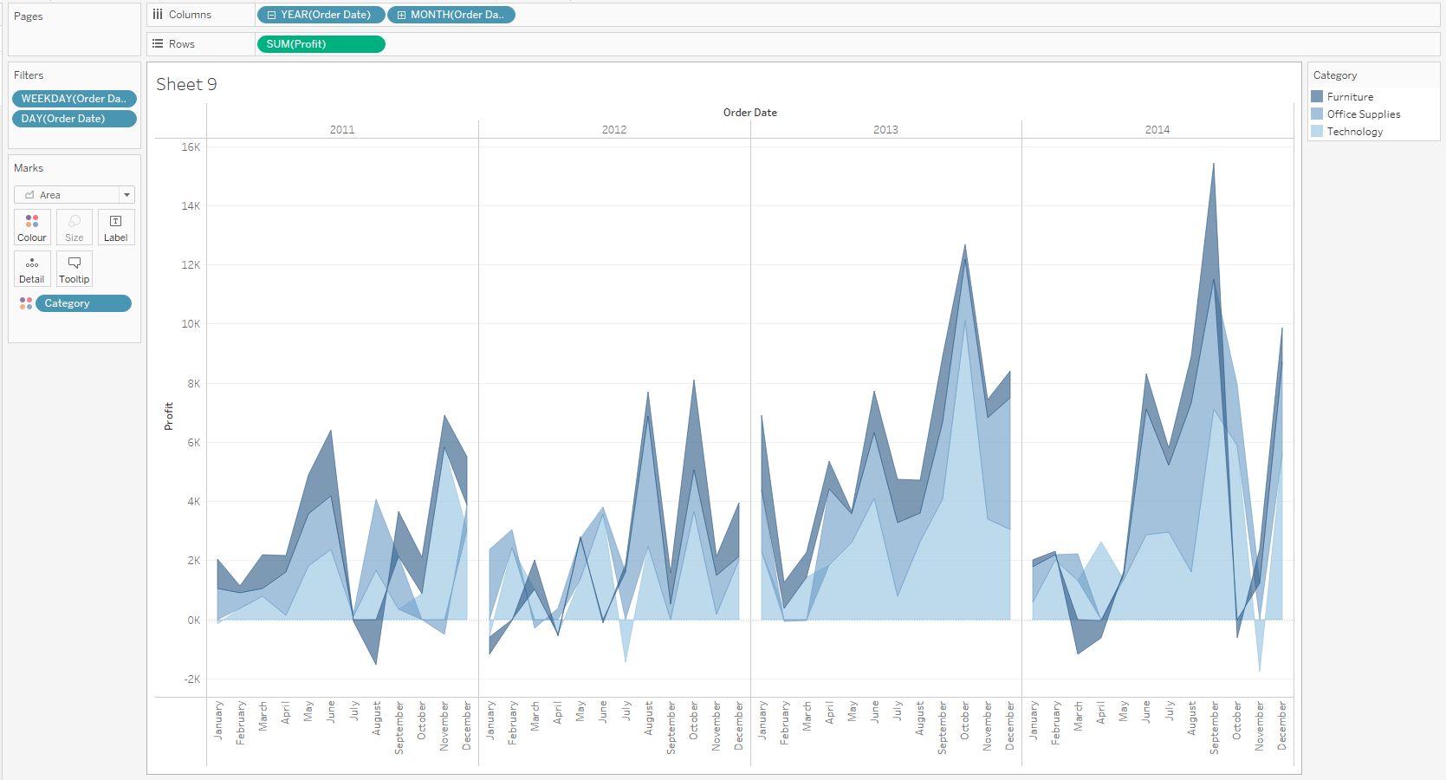

These are the Basic and LOD visualizations